Notes on Figures
Fig_L_AqVuln.jpg LAVA: (full report http://www.adgeo.net/content/lava/LAVA_Report_v1.1.pdf) Using evidential themes representing effective karst, overburden on FAS, and soil hydraulic conductivity, weights of evidence was applied to generate a response theme (Figure 18), which is a GIS raster consisting of posterior probability values ranging from 0.00219 to 0.05295 across the study area. These probability values describe the relative probability that a unit area of the model will contain a training point – i.e., a point of aquifer vulnerability as defined above in Training Points – with respect to the prior probability value of 0.01030. Prior probability is the probability that a training point will occupy a defined unit area within the study area, independent of evidential theme data. Probability values at the locations of 14 of the 18 training points are above the prior probability, indicating that this model is a strong predictor of training point locations.
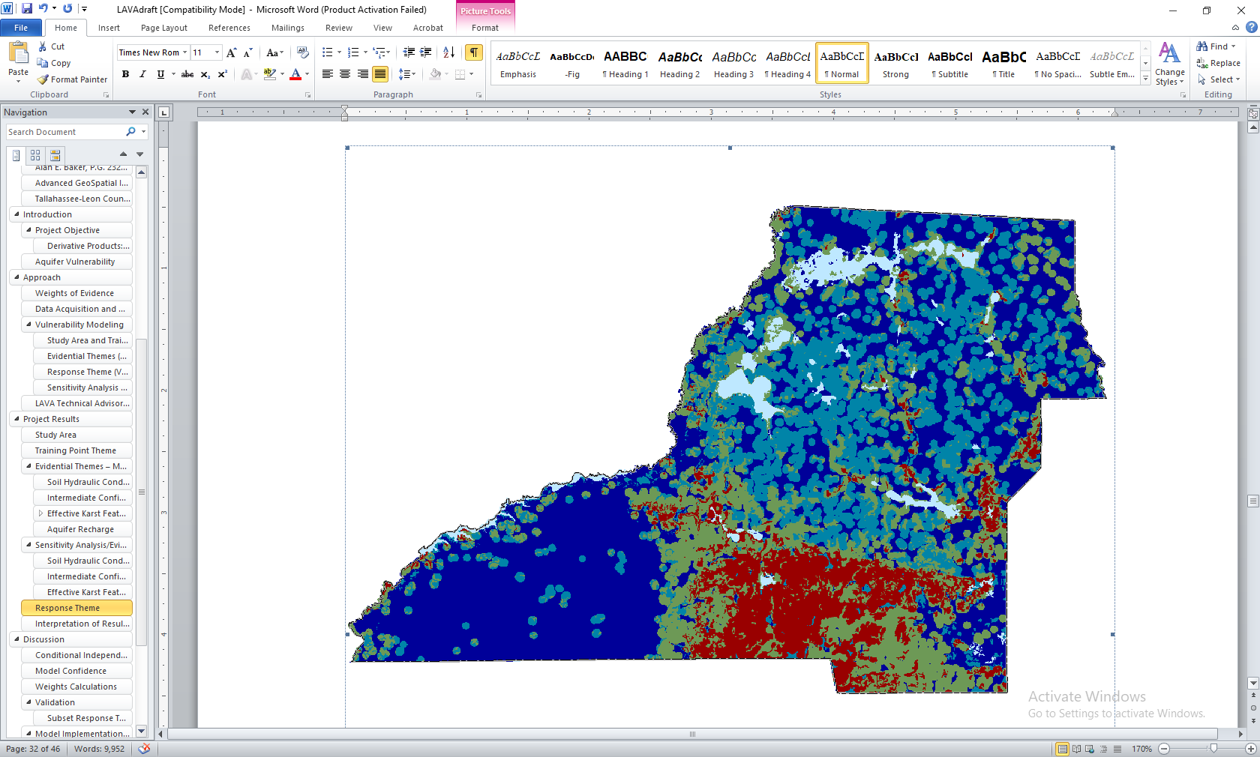
The response theme was broken into classes of relative vulnerability based on the prior probability value and on inflections in a chart in which cumulative study area was plotted against posterior probability (Figure 19 below). Higher posterior probability values correspond with more vulnerable areas, as they essentially have a higher chance of containing vulnerability based on the definition of a training point. Conversely, lower posterior probability values correspond to less vulnerable areas as they essentially have a lower chance of containing vulnerability based on the definition of a training point.

Figure 19. Vulnerability class breaks are defined by selecting where a significant increase in probability and area are observed.

As expected, the LAVA model response theme indicates that the areas of highest vulnerability are associated with areas where the overburden on the FAS is thin to absent, of dense effective karst-feature distribution, and of higher soil hydraulic conductivity. Conversely, areas of lowest vulnerability are determined by thicker overburden sediments, sparse karst-feature distribution, and lower soil hydraulic conductivity values.
Fig_Existing.jpg Existing Land Use: Existing land use layer for the model was taken from the TLCGIS Data Hub (https://geodata-tlcgis.opendata.arcgis.com/datasets/existing-land-use-2018). From the TLCGIS metadata:
The Existing Land Use Map was developed by the Tallahassee-Leon County Planning Department in the 1970s and has been updated annually since 2005 to reflect changes in current land use. Existing land use is parcel based with each parcel assigned a single land use. Utilizing new construction permits completed in the past year, the land use for parcels are updated to reflect the new construction (ordemolition) that was completed.The existing land use classification is comprised of 20 primary land use categories: Single-Family Detached, Single-Family Attached, Two-Family Dwelling, Multi-Family, Hotel-Motel, Medical, Retail, Office,Warehouse, Government Operation,Schools / Colleges / Universities, Open Space (5 categories),Religious-Non-Profit,Transportation/Communications/Utilities,Water,Vacant,Each land use category is further broken down into 49 sub-types or “patterns”.Every reasonable effort has been made to ensure the accuracy of these data, however accuracy is not guaranteed. Users with questions or comments should email the Planning Department or call 850-891-6400. “
Symbology:
- Gov/School/Municipal=Government operation, schools, colleges, universities
- Retail/Motel/Medical=Hotel, motel, medical, office, religious, nonprofit retail
- Housing=Multi family, single family attached, single family detached Mobil home, two family dwelling
- Greenspace=Open space common areas, open space recreation/parks, open space resource protection, state and national forest, open space
- Trans/Utility=Transportation, communications, utilities
- Vacant
- Warehouse
- water
Fig_Future_land Use res units.jpg Future Land Use 2 figures: 1st Fig is Future land use layer for the model was taken from the TLCGIS Data Hub (https://geodata-tlcgis.opendata.arcgis.com/datasets/future-land-use). This feature layer displays Future Land Use district boundary polygons for the City of Tallahassee and Leon County, Florida. The Future Land Use layer is maintained by Tallahassee Leon County Planning Department (TLCPD) last update was December 5, 2019.
Created a new field for symbology based on groups of “like” future land uses:
- Activity Center=unchanged
- Agriculture=unchanged
- Government Operational & Educational Facilities=Government & Institutional
- Industrial and Industry & mining=Industry & Mining
- Water and Lake Protection=Lake Protection & Water
- Recreation/Open Space, Open Space/Stormwater Facilities=Open Space
- Rural, Rural Community, Rural community with Residential preservation Overlay, Rural with Residential PreservatiOverlay, Urban Fringe, Urban Fringe with Residential Preservation Overlay, Urban Residential, Urban Residential 2, Woodville Rural Community, Woodville Rural Community with RP Overlay=Rura/Urban Fringe/Residential
- Bradfordville Mixed Use, Mahan Gateway Node, Planned Development, Residential Preservation, Suburban=Suburban/Residential
Fig_Future_land Use res units.jpg 2nd Fig is the futlu layer with the residential units calculated. Misha and Marcy at TetraTech used the Leon County Land Development Code (I have a pdf copy if you need it) to come up with the Residential units.
Created a second figure that is symbolized only by Max Res Denisity Units as calculated by Tetra Tech.
As per the landuse code.
LU | MaxDenPerAcre
AC | 45.00
AG | 0.10
EF | 0.00
GO | 0.00
I | 0.00
IM | 0.00
LP | 0.50
MGN | 16.00
MU | 20.00
OS | 0.00
OSS | 0.00
PD | 20.00
R | 0.10
RC | 4.00
RC-RPO | 4.00
RP | 6.00
R-RPO | 0.10
SUB | 20.00
UF | 0.33
UF-RPO | 0.33
UR | 10.00
UR-2 | 20.00
W | 0.00
WRC | 4.00
WRC-RPO | 4.00

Fig_Existing Site Characheristics Soils.jpg (Soils Hyd K): The rate that water moves through soil is a critical component of any aquifer vulnerability analysis, as soil is literally an aquifer system’s first line of defense against potential contamination (Arthur et al., 2005). Two parameters of soils were evaluated for input into the LAVA model: soil hydraulic conductivity, which is the “amount of water that would move vertically through a unit area of saturated soil in unit time under unit hydraulic gradient” (U.S. Department of Agriculture, 2005);
Countywide datasets representing soil hydraulic conductivity were developed to be used as input into the LAVA model. Multiple empirical values are reported in soil surveys representing various zones in each soil column underlying a particular soil polygon. Further, multiple columns may be reported for a single soil polygon. Because the model requires a single value for each soil polygon, two steps are used. First, representative values for each horizon in a column are combined using a harmonic sum of the weighted mean. Second, because multiple columns may be reported for a soil polygon, the harmonic sum values are averaged into a single value for each polygon.
Soil hydraulic conductivity ranges from 1.80 to 20.74 inches per hour (in/hr) across the study area. Test modeling indicated that areas underlain by 20.74 to 12.72 in/hr were more associated with the training points, and therefore associated with higher aquifer vulnerability. Conversely, areas underlain by 12.71 to 1.80 in/hr soil hydraulic conductivity were less associated with the training points, and therefore lower aquifer vulnerability. Based on this analysis, the evidential theme was generalized into two classes as displayed in Figure 14
Currently symbolized in inches per hour as a color ramp. If you want to classify by a range just let me know and tell me what range you’d like to see. For instance, 0-5 in/hr, 5-10 etc.
Fig_Existing Site Characheristics Septic Tank DominantCondition.jpg (Soils data mugwat table):
Join soils table to MUAGGATT table and display on muaggatt.engstafdcd which is aliased as Septic Dominant Condition 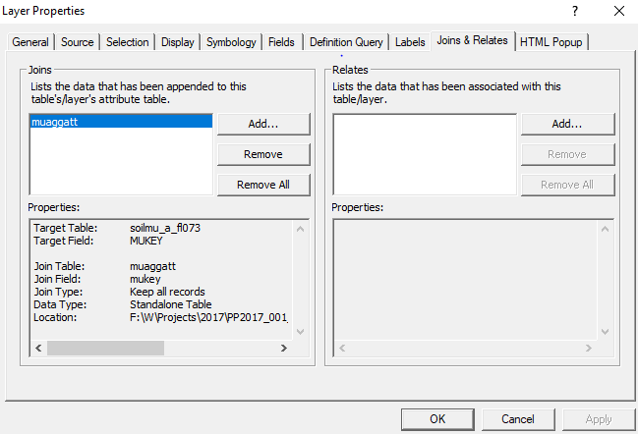
- 27 engstafdcd ENG - Septic Tank Absorption Fields - Dominant Condition
- 28 engstafll ENG - Septic Tank Absorption Fields - Least Limiting
- 29 engstafml ENG - Septic Tank Absorption Fields - Most Limiting
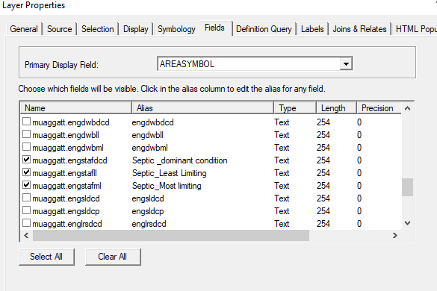
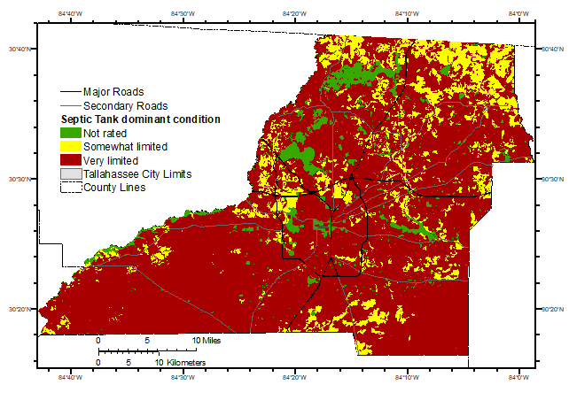
Fig_Existing Site Characheristics Soils_KSATVALUES.jpg (Soils KSAT):
Saturated Hydraulic conductivity - (Ksat) is the single most scientifically valuable parameter for phenomena related to soilwater flow and transport. Ksat quantitatively defines a soil’s capacity to transmit water. Traditionally, NRCS (formerly SCS) used the term “permeability” for water-flow phenomena and used Permeability Classes (PC), which have prescribed percolation rate ranges (originally inches/hr). The PC and associated percolation rates are commonly mistaken to be Ksat. The confusion between Ksat, the term “permeability,” and the Permeability Classes arises for several reasons (Wysocki et al., 2002). A primary reason is that the term “permeability” has three meanings in soil science.
Saturated hydraulic conductivity (Ksat) is the ease with which a saturated soil can transmit water through the pore space. Ksat is formally defined as the proportionality factor that relates water flow rate to the hydraulic gradient in Darcy’s equation (see Discussion). Ksat is a measurable soil property, or it may be estimated from other properties (texture, structure, bulk density, etc.). Direct field Ksat measurement is possible with various devices (Amoozemeter, Guelph Permeameter, double-ring infiltrometer). Multiple (e.g., USDA-NRCS 2–84 September 2012 ≥5) measurement replications are needed on a horizon or layer to capture the natural variation. Record an estimated Ksat class or a measured Ksat value for each horizon/layer. If measured, record the Average Ksat, Standard Deviation, Replication Number (n), and Method. See NSSH, Exhibit 618.88 (Soil Survey Staff, 2012c) for guidelines for Ksat Class estimation using texture and bulk density (see p. 7–10).
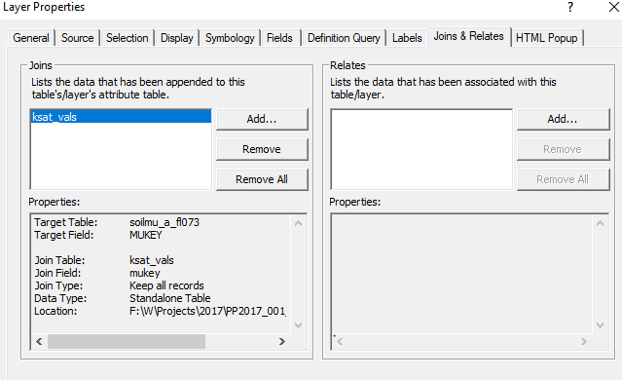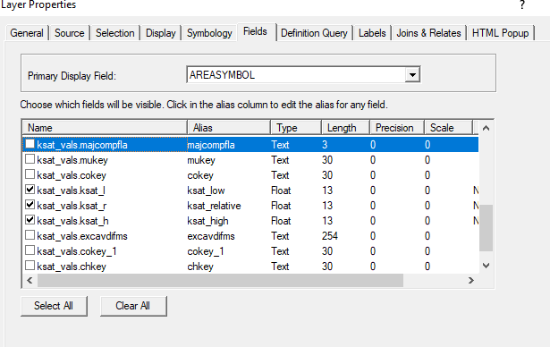
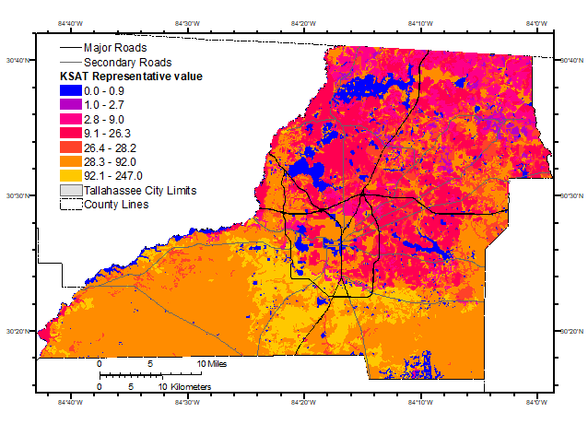
Fig_Recharge.jpg Recharge: From the FDEP Metadata-A digital dataset was developed from selected reports published by the USGS as part of the RASA studies of the Floridan Aquifer System in the 1980's. These reports contain maps and data depicting the extent, and elevation of both time-stratigraphic and hydrogeologic units. The dataset was created by digitization of electronic copies of selected 1:2,000,000 scale paper maps included in USGS PP 1403B (Miller 1986). This shapefile depicts the extent of the upper confining unit and the degree to which it confines the Floridan aquifer system.
Who created the data: Bellino, Jason C.
Date and time: 2011
Publisher and place: U.S. Geological Survey, Reston, VA
Series name: Data Series
Series issue: 584
Fig_Current treatmentType.jpg Treatment Type Available: this is a figure showing the “best estimate” of treatment type. Values will be Tallahassee Sewer, Septic, Talquin Sewer, national forest or open land. For natural areas I downloaded the latest version (Aug2019) of Florida Natural Areas Inventory (FNAI) data.
- Select all features within 250 feet of City Sewer Lines = 70,152 selected
- Select all features touching Talquin Sewer system = 5,746 parcels selected, 200 were already selected as City Sewer but have been changed to Talquin
- Selected all features that have their center within the FLMA polygons – 333 selected with 7 from Talquin and 40 from Tallahassee changed to Open Land
- All remaining parcels are labeled as Septic =33,174
Fig_KarstFeatures.jpg Karst Features: Waterbodies and Potential Karst Features, the potential karst features. Many of the lakes are called potential karst because they are known to have sinkholes and swallets in the lake bottoms. The only one they missed is Lake Miccosukee over to the east (but technically it’s in Jefferson County). Also, In my professional opinion, all the lakes to the southeast in the unconfined area are karst related and have a connection to the underlying aquifer.
Septic Parcels and future septic parcels. Start with Treatment type layer, which for GIS purposes is the Tax_Parcels with the treatment type category as septic. Existing land use has a category for Residential Units. Take the Tax Parcels that are Potential septic. Will now try to apply a residential Density Unit for the “vacant” parcels
- Added a field for if in or out of Woodville project area and another if res units from existing LU = 0. In boundary =951 and out boundary = 32,223
- Added a field is called Vacant. Query was “Existing land use.Residential Units = 0 and then executed a select by location to tax parcels (Potential Septic) and it is yes/no. Selection was 7526 parcels were vacant and 25,648 are occupied.
- To do this, I will intersect the TAX_Parcels (Potential Septic) with the Potential Future Dwellings polygon and recalculate the RDU based on the parcel acrages and not the futlu polygons which are huge. Did that and recalculated but …. Made a mistake because I included developed parcels.
- To fix, performed a spatial join with existing land use to get the values that are NOT = 0. If there is a value greater than 0 it will be put in the field ActDenperA (actual density per acre).
Fig Septic Parcels with buildout. There was a lot of manipulation and start/stop/begin again to get this figure. Basically, if the lot is potential septic it is in here. If it has a residential unit value from the 2018 land use, it is carried over to the potential buildout. To get the number for the remaing 7,700 I had to use the Potential Future Dwellings layer and performed a spatial join. This is not an exact calculation so I took avg, min and max values for potential dwellings from the join. This is done because in some cases, the parcel intersected more than one polygon in the future land use (Potential future Dwellings) layer. Add to that, some parcels came out with a potential res unit of 0.3 or 0.1 but were surrounded by areas that were equal to 1. So, I took the minimum value, say 0.333 then calculated a new maximum of 1, this was only done for parcels that had both the min and max below 1. These new values were used to calculate a minimum potential build out and a maximum potential build out. The values were averaged to create the new bailout figure.

